ASSIGNMENT-4.1
NAME: G.Rishitha
H.T.NO:2303A52149
BATCH:35

- Customer Email Classification
A company receives a large number of customer emails every day
and wants to automatically classify them into the following
categories:
• Billing
• Technical Support
• Feedback
• Others
Instead of training a new machine learning model, the company
decides to use prompt engineering techniques with an existing large
language model.
Tasks
1. Prepare five short sample emails, each belonging to one of
the above categories.
2. Write a zero-shot prompt to classify a given email into one of
the categories without providing any examples.
3. Write a one-shot prompt by including one labeled email
example and ask the model to classify a new email.
4. Write a few-shot prompt by including two or three labeled
email examples and ask the model to classify a new email.
5. Compare the outputs obtained using zero-shot, one-shot, and
few-shot prompting techniques and briefly comment on their
effectiveness.
CODE:
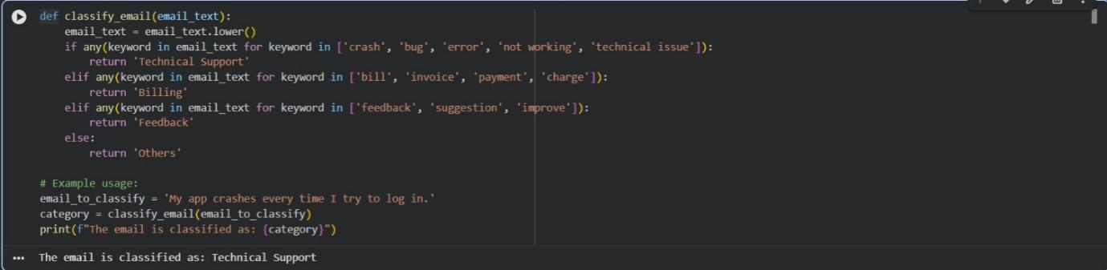
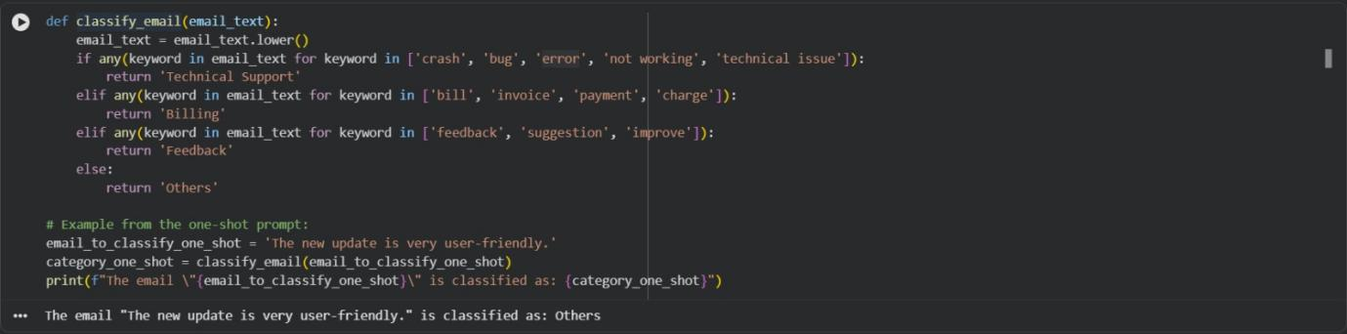
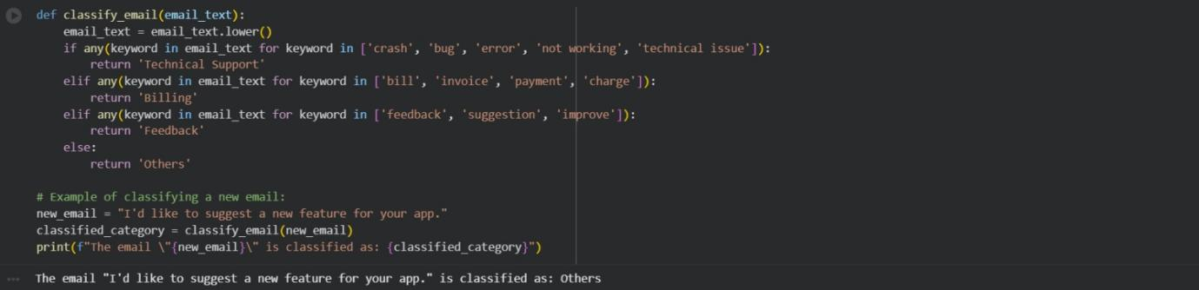
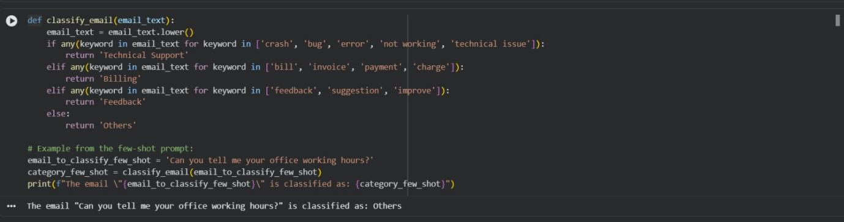
Comparison for these prompts:
Zero-shot, one-shot, and few-shot prompting mainly differ in how much guidance is given to a language model through examples. In zero-shot prompting, no explicit prompt string or examples are provided; the task is implied, and classification is done directly using predefined logic, similar to an LLM relying only on its pre-trained knowledge, which works for simple but not nuanced tasks. One-shot prompting introduces a prompt string containing the task description and a single example with its correct category, helping the model better understand the expected output format and intent, thus improving performance over zero-shot for moderately complex tasks. Few-shot prompting further extends this by including multiple examples within the prompt, giving richer context and allowing the model to recognize patterns and generalize more effectively, making it the most accurate and reliable approach for complex or ambiguous classifications. In rule-based simulations, outputs remain the same due to fixed logic, but in real LLM scenarios, performance clearly improves from zero-shot to few-shot prompting.

- Intent Classification for Chatbot Queries
A company wants to deploy a chatbot to handle customer queries.
Each query must be classified into one of the following intents:
Account Issue, Order Status, Product Inquiry, or General Question
using prompt engineering techniques.
Tasks to be Completed
1. Prepare Sample Data
Create 6 short chatbot user queries, each mapped to one of
the four intents.
2. Zero-shot Prompting
Design a prompt that asks the LLM to classify a user query
into the given intent categories without examples.
3. One-shot Prompting
Provide one labeled query in the prompt before classifying a
new query.
4. Few-shot Prompting
Include 3–5 labeled intent examples to guide the LLM before
classifying a new query.
5. Evaluation
Apply all three techniques to the same set of test queries and
document differences in performance.
CODE:
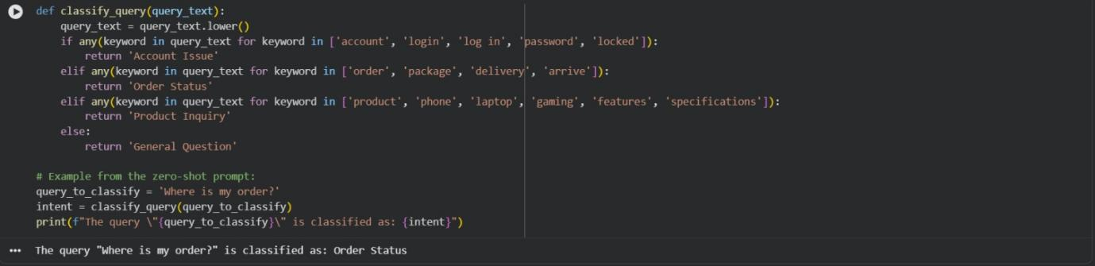
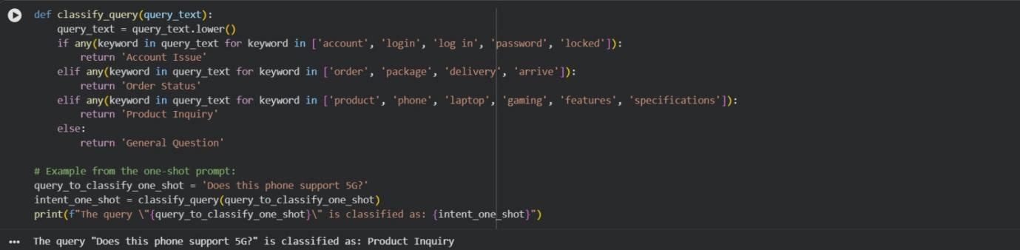
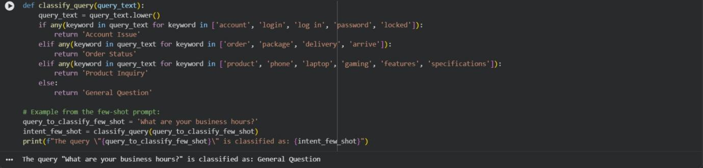
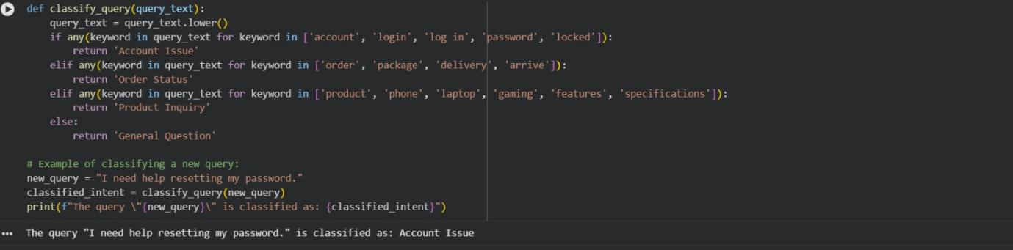
Evaluation (Comparison of Zero-shot, One-shot, and Few-shot Prompting):
When applying zero-shot, one-shot, and few-shot prompting to the same set of chatbot intent classification queries, the difference lies in how accurately and consistently the intents are identified. In zero-shot prompting, the LLM relies entirely on its pre-trained knowledge and the intent labels provided in the instruction, which works reasonably well for clear queries but may misclassify ambiguous or overlapping intents (for example, confusion between Account Issue and Order Status). One-shot prompting improves performance by providing a single labeled example, helping the model better understand the expected intent boundaries and output format, leading to more consistent results. Few-shot prompting is the most effective, as multiple labeled examples allow the LLM to recognize patterns across different intents, handle varied phrasing, and resolve ambiguity more accurately. Overall, while zero-shot is suitable for simple use cases, one-shot offers better reliability, and few-shot prompting delivers the highest accuracy and robustness for real-world chatbot intent classification.

